LIST OF HUMONOID ROBOT

ATLAS

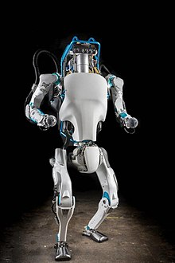
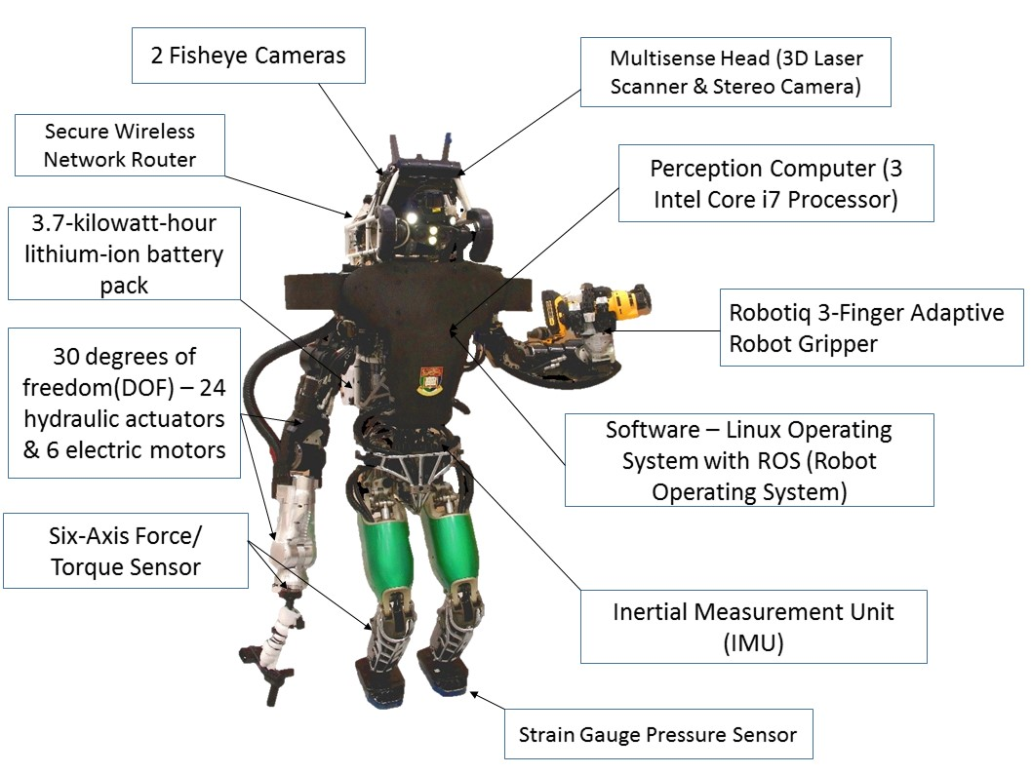

ABOUT:
Atlas is a bipedal humonoid robot primarily developed by the American robotics company boston dynamics with funding and oversight from the U.S. defence advance research projects agency (DARPA).

Atlas is based on Boston Dynamics' earlier petman humanoid robot .

KAY SPECS:

- It is 1.8-meter (6 ft) robot
- It has four hydraulics -actuated limbs
- Constructed of aluminum and titanium.
- Weigh approx 150 kg.
- Its limbs possess a total of 28 DOFNeck: 1 DoF; Arm: 6 DoF x 2; Torso: 3 DoF; Leg: 6 DoF x2).
- It head having LIDAR to protect from obstacle.
- Atlas is equipped with two vision systems – a laser rangefinder and stereo camera.
- On board real time control computer.
- Chest depth 0.56 meter.
- Shoulder depth 0.76 meter.
- 480v 3-phase at 15 kwt.
- 10 Gbps fiber optics Ethernet.
- Interefacing with C++ and ROS API.

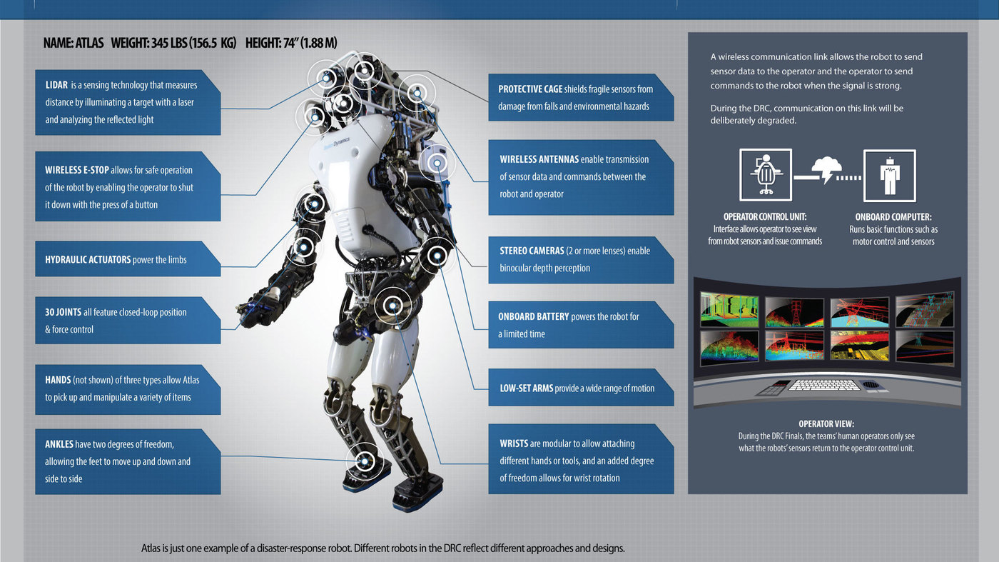
APPLICATION:
- Basically atlas is made for rescue and search operation for defence purpose.
- It can shutting off valves.
- opening doors and operating powered equipment in environments where humans could not survive.
EVOLUTION:
- Atlas debuted(july 2013)
Standing 6-foot-2-inches and tipping the scale at 330 pounds
- Atlas Balanced(october 2013)
the robot balancing on one leg, jogging over rocks, and being hit with projectiles.
- Atlas shrunks(january 2015)
This slimmed-down model carries over only the lower legs and feet of the robot’s original design. It now boasts lighter materials, improved articulation, extra sensors and perception computers, and much quieter operation.
- Atlas shrunk again(february 2016)
standing at just 5-foot-9-inches, a head shorter than the original models, it is designed to be able to operate both indoors and outdoors, across a range of terrain — including snow.
- Atlas fell(august 2017)
- Atlas Flipped(november 2017)
Seeing a 5-foot-9-inch robot perform this feat underlines just how far it has come, while showcasing its amazing agility, balance, and control
- Atlas jogged(may 2018)
this is the biggest achivement for atlas ,it impressed most as compare to another features.

PEPPER
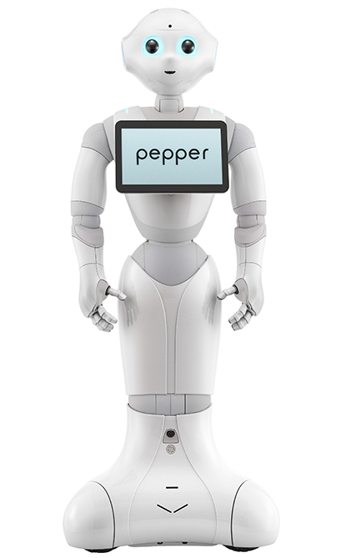
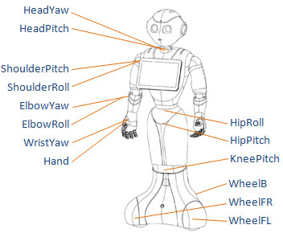
ABOUT:
- Pepper is a semi-humanoid robot manufactured by softbank robotics.
which is owned by softbank, designed with the ability to read emotions. It was introduced in a conference on 5 June 2014 .
pepper robot having currently two version.

KEY SPECS
- Height: 1.20 metres (4 ft)
- Depth: 425 millimetres (17 in)
- Width: 485 millimetres (19 in)
- Weigh is 28 kilograms .
- It use lithium ion battery having Capacity: 30.0Ah/795W
- it having 10.1 inch display.
- It head consists of Mic x 4, RGB camera x 2,3D sensor x 1, Touch sensor x 3
- It chest having one gyro sensor and hand having 2 touch sensor.
- It legs having Sonar sensor x 2, Laser sensor x 6, Bumper sensor x 3, Gyro sensor x 1
- plateform used ids NAO iq OS.
- It having total degree of freedom accordin to its part are Head (2°), Shoulder (2° L&R), Elbow (2 rotations L&R), Wrist (1° L&R), Hand with 5 fingers (1° L&R), Hip (2°), Knee (1°), Base (3°).
- it having total 20 motor.
APPLICATIONS:
- Pepper is used in over a thousand homes in Japan.
- Pepper is used for educational purpose Pepper is available as a research and educational robot for schools, colleges and universities to teach programming and conduct research into human-robot interactions.
- Pepper is currently being used as a receptionist at several offices in the UK and is able to identify visitors with the use of facial recognition, send alerts for meeting organisers and arrange for drinks to be made. Pepper is said to be able to chat to prospective clients.
ROMEO
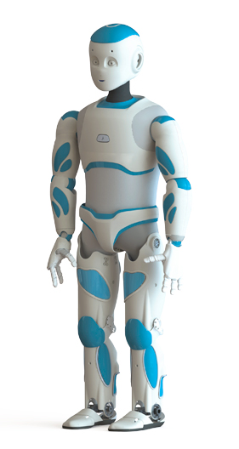

Developer- Aldebaran Team
Applicaion: to become perfect companion robot
Features:
Taller than pepper and nao robot.
Fitted with two cameras in its eyebrows
4 microphones and 2 Loudspeakers
4 x CPU:
- 3 on Head motherboard
- 1 on Torso motherboard

CPU PROCESSOR | ATOM Z530
Cache memory | 512 KB
Clock speed | 1.6 Ghz
FSB speed | 533 mHz
RAM | 1 GB
FLASH MEMORY | 2 GB
MICRO SDHC | 8GB

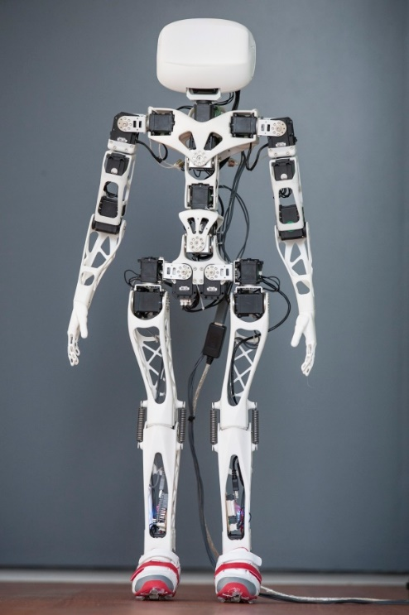
POPPY

Developer- Inria Flowers Lab
Features:
Parts are printed using polyamide material.
- Dimensions: H:84 W:25 T:10 (cm)
- Mass: 3.5 kg
- Motors: 21x Robotis Dynamixels MX-28, 2x Robotis Dynamixels MX-64, 2x Robotis Dynamixels AX-12
- Options: 16x Forces sensors (FSR), 2x PS Eye, 1x IMU (9DDL), 4.3″ LCD 480 x 272 px, Stereo Micros, Raspberry Pi
- Cost: 7500-8000€

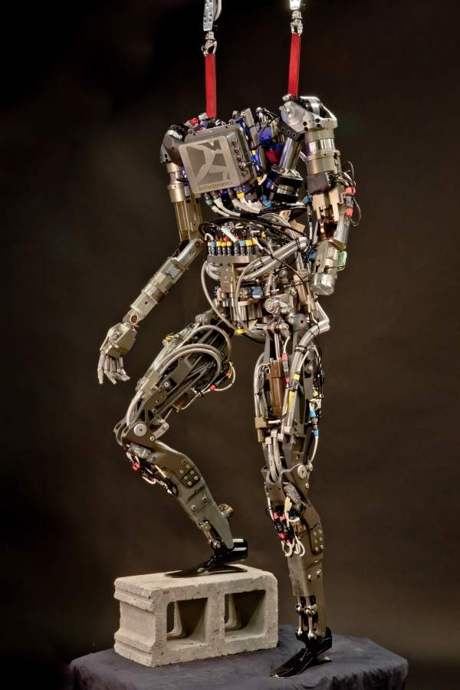
PETMAN

Developer: Boston Dynamics
Features:
Anthropomorphic design. Equipped with custom hydraulic actuators.
SPEED: 6.44 km/h | 4 mph
can walk, squat, and do push-ups
It was developed to test chemical-resistant military gear

ESTIMATED INVESTMENT: $26.3m
REEM – C
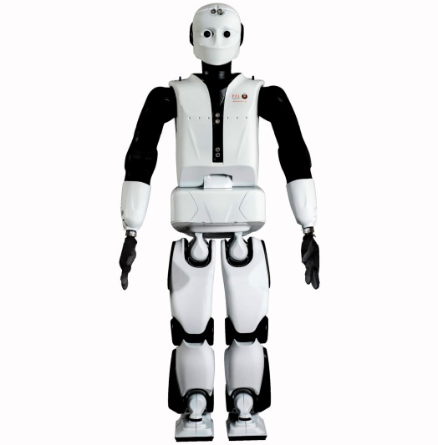
Developer :
- Pal rotics
Application :
- It is designed as a research platform to
study navigation, vision, AI, and human-robot
interaction.
Features :
- Reem – C is as tall as person and has smart desingn (1.70 m , 100g).
- 2 DOF head stereo camera , Mouth speakers and 4 Microphones.
- 7 DOF Arms 3 , DOF human like hand and 6 DOF legs.
- Stable and smooth walking (1.5 Km/h).
- REEM-C is a bipedal humanoid
- Navigates Autonomously

Cost : 1 million euro

QRIO

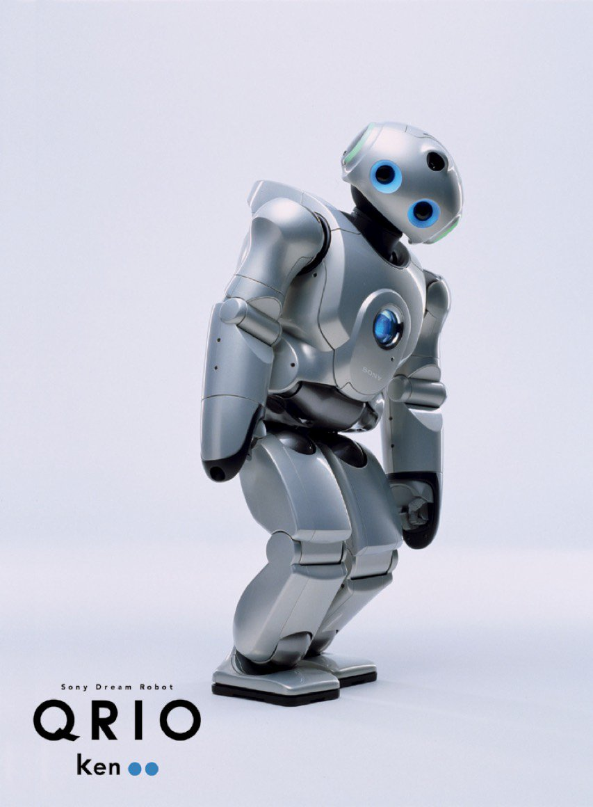
Developer :
- SONY
Application :
- Qrio is a snall entertainment humanoid that can hear, speak, sing, walk, run, dance, recognize faces and grasp objects .
Features :
- Humanoid Biped
- Qrio was small in size (58 cm, 6.5 kg).
- Stable and smooth walking (1. Km/h).
- Seven microphones in its head.
- Contains three microprocessors, each with 64 megabytes of memory.
- Capable of recognizing speech and faces and picking itself up if it falls.
- It’s features include voice and face recognition
- Ability to avoid any obstacles
Cost : Not yet for sale

It was exceptionally advanced for its time, and sadly it was canceled in 2006. Sigh.

ASIMO (Advanced Step in Innovative Mobility)
1st Humanoid Robot of world by Honda.
- Sensors :- Stroke, sound, face detection, motion, squeeze, proximity
- Key specs. :-
- 6-axis area sensor (on foot).
- Walking- 1.7Km/h , Running- 4.3Km/h
- Battery- 51.8V, Li-ion battery (1hr backup).
- 57 DOF
- Height-130cm
- Airborne time- 0.08sec
- Earlier versions:- E0(1st bipedal), E1, E2, P0, P1(1st humanoid), P2.
- Actuators- servomotor + harmonic speed reducer + drive unit.
- Walking stability-
- Floor reaction control, foot planting location control, target ZMP control.
- Contact sensors on foot sends the foot position to robot
- during walking floor reaction increases by 1.2-1.4 times body weight.
- uses i-walk technology for COG controlling.
- Features- Recognizing moving objects, recognizing postures & gestures, environment recognition, distinguishing sounds, face recognition.
- Uses IC communication technology to recognize people in vicinity.
- Stereo system-
- imaging sensor- 1/3’’ color CCD x2
- picture element- 768(H) x 240(V)
- stereo frame rate- 20fps.
- Created for being helper to people.
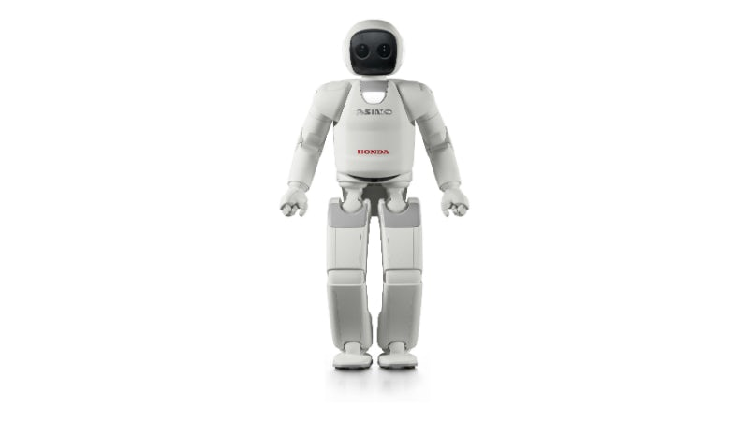
NAO (V6)
- It was manufactured by Softbank Robotics in 2008.
- Key specs:-
- Height- 57.4, Weight:-5.5Kg
- Battery- 62.5Wh, 21.6V (90min backup)
- 25 DOF
- CPU- Intel Atom E3845, quad core, 1.91GHz
- RAM- 4GB DDR3, ROM- 32GB SSD
- OS- NAOqi 2.8 (open embedded based)
- Languages- C++,C, python, Java, matlab, urbi, .Net
- Body Material :- ABS-PC/PA-66/XCF-30
- Sensors:- four microphones, sonar rangefinder, two infrared emitters & receivers, inertial board, nine tactile sensors, eight pressure sensors
- Expressions- anger, fear, sadness, happiness, exciting, being proud. (eye depicts colored emotions).
- It gets its walk stability by feedback from his joint sensors.
- Its mouth is a camera basically.
- It has 4 sonar sensors on its chest for object detection.

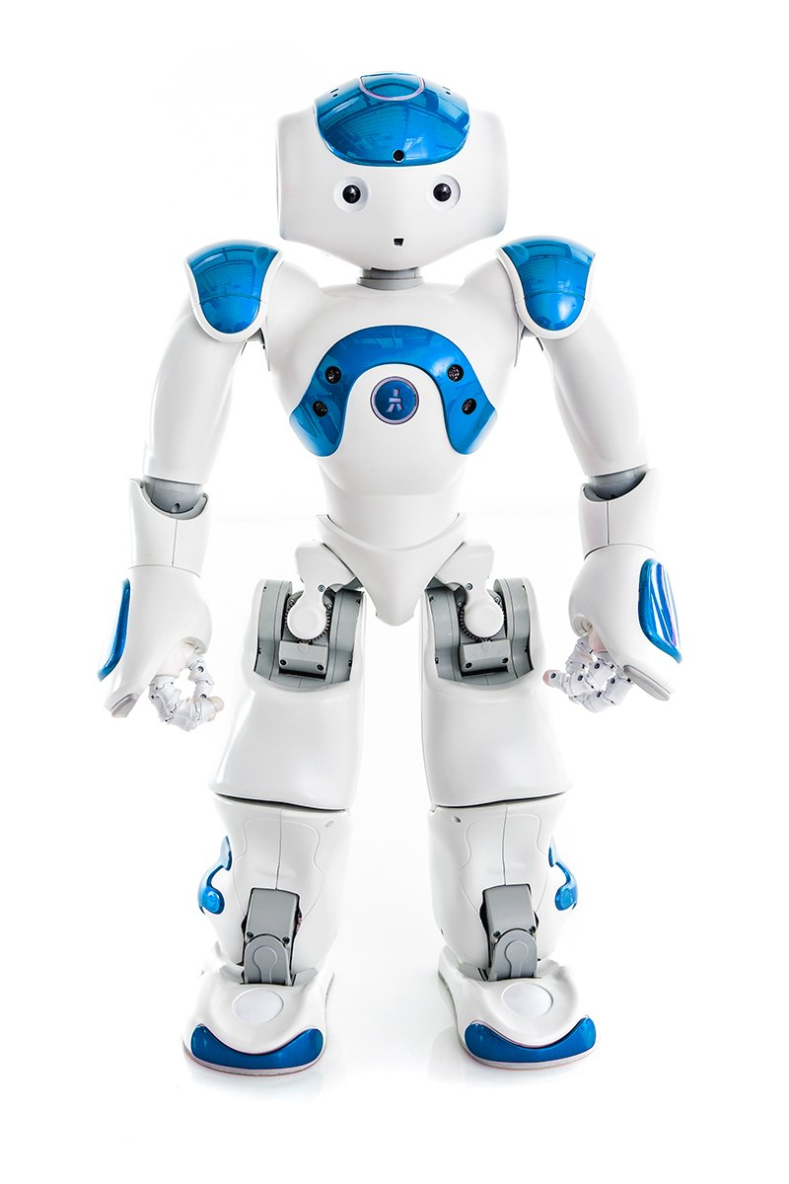

LIST OF COMPETITION HELD FOR HUMONOID ROBOTS
- DARPA CHALLENGE
- IEEE HUMANOID ROBOT RACING
- ROBOCUP HUMANOID LEAGUE(SOCCER)
- HUMANOID ROBOT APPLICATION CHALLENGE NATIONAL TIWAN NORMAL UNIVERSITY
- ROBOTICS OLYMPAID: ROBO COP

FOOTSTICK *2

